**7.RP.A.2** Recognize and represent proportional relationships between quantities.

***QuickAuthor:***

Filemaker #1371 - problem_7RPA2_1 (Multiple choice)

**Problem Statement:**

Danielle will use the instructions below to make a cleaning solution.

Add 13 cups of water to every 2 cups of concentrated cleaner.

**Question 1:** Filemaker #1371 - problem_7RPA2_1

Which of the following proportions can be used to find ω, the number of cups of water Danielle will add to 5 cups of concentrated cleaner?

**Hint 1:**

**Show:**

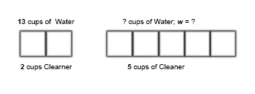

**Say:**

How can we show a proportion that tells us how many cups of water Danielle will need to add to 5 cups of cleaner?

Danielle added 13 cups of water to 2 cups of cleaner, how many cups of water *w* are needed for 5 cups of cleaner?

**Hint 2:**

**Show:**

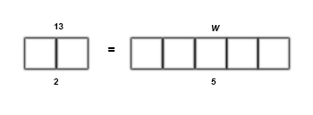

**Say:**

13 over 2 equals *w* over 5

**Answers:**

**a.** \frac{13}{2}= \frac{w}{5}

**b.** \frac{13}{}2= \frac{\5}{\omega }

**c.** \frac{13}{}5= \frac{\omega }{\2 }

**d.** \frac{5}{}2= \frac{\13}{\omega }